1. 图表初始化（均为ms）

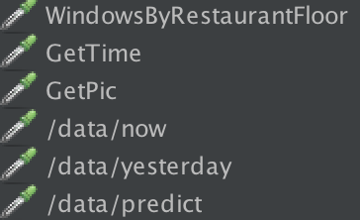

* 顺序访问

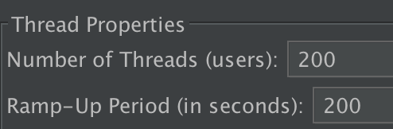

Summary Report

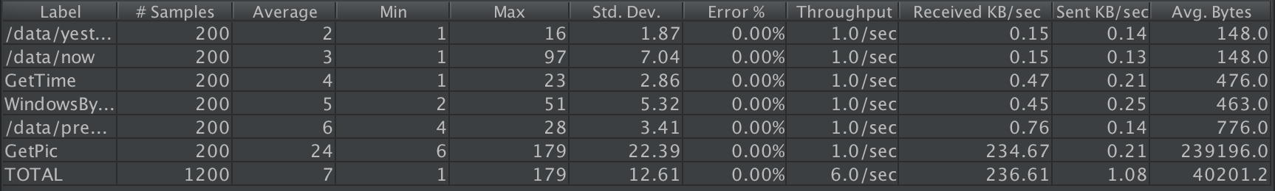

Aggregate Report

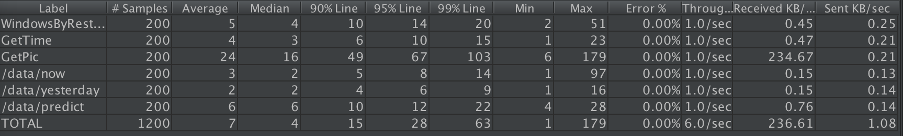

* 同时访问

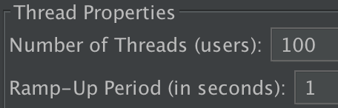

Summary Report

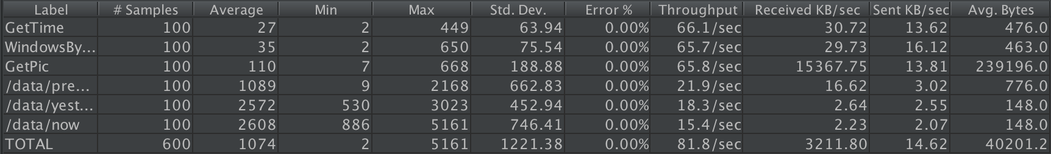

Aggregate Report

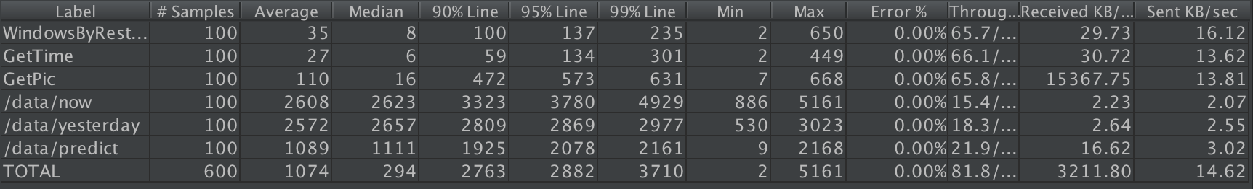

1. 访问主页



* 顺序访问

Summary Report

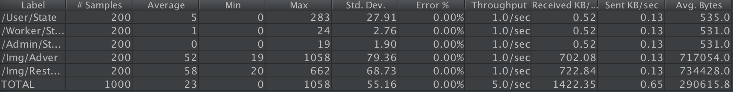

Aggregate Report

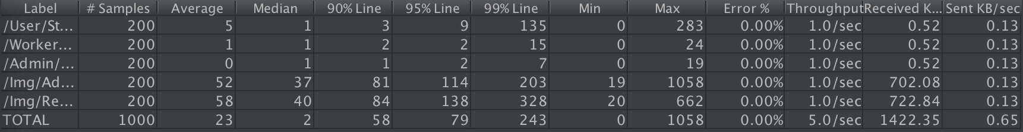

* 同时访问

Summary Report

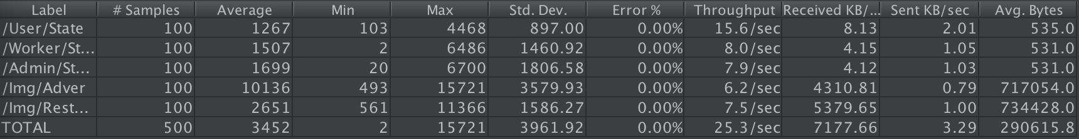

Aggregate Report

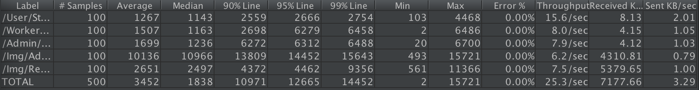

1. 全局搜索菜品



* 顺序访问

Summary Report



Aggregate Report



* 同时访问

Summary Report

Aggregate Report



1. 比较图表



* 顺序访问

Summary Report

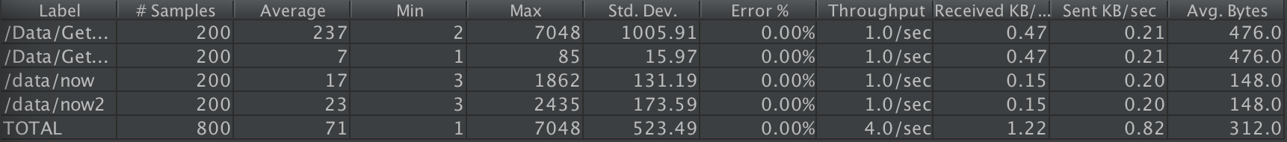

Aggregate Report

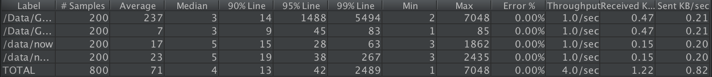

* 同时访问

Summary Report

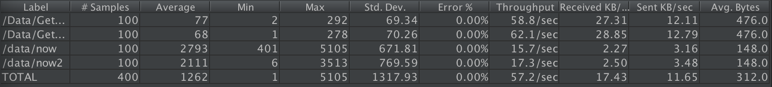

Aggregate Report

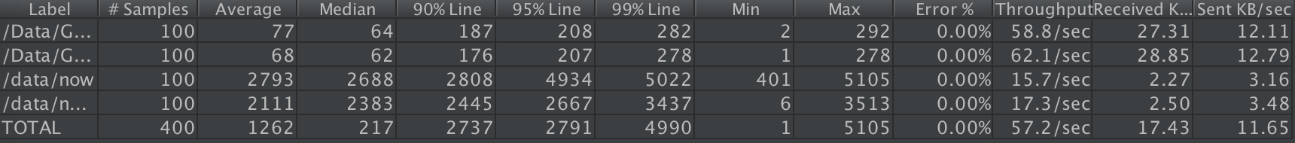

1. 用户个人信息访问



* 顺序访问

Summary Report

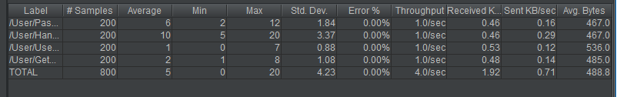

Aggregate Report

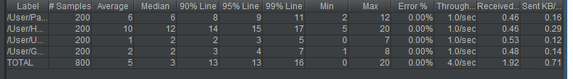

* 同时访问

Summary Report

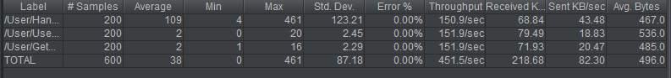

Aggregate Report

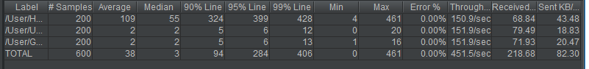

1. 个人标签访问



* 顺序访问

Summary Report

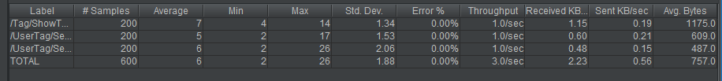

Aggregate Report

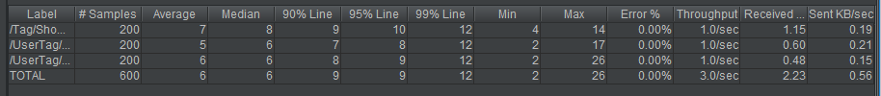

* 同时访问

Summary Report



Aggregate Report



1. 历史浏览记录访问



* 顺序访问

Summary Report



Aggregate Report



* 同时访问

Summary Report



Aggregate Report



1. 用户收藏访问



* 顺序访问

Summary Report

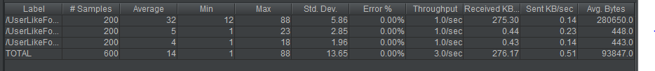

Aggregate Report

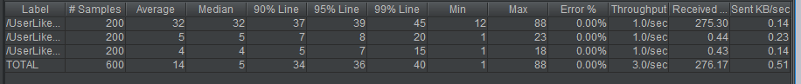

* 同时访问

Summary Report

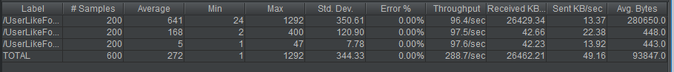

Aggregate Report

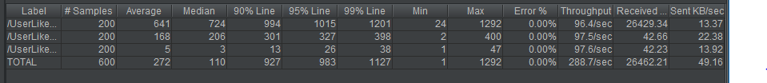

1. 用户个性化推荐

* 顺序访问

Summary Report



Aggregate Report



* 同时访问

Summary Report



1. 用户评论



* 顺序访问

Summary Report



Aggregate Report



* 同时访问

Summary Report



Aggregate Report

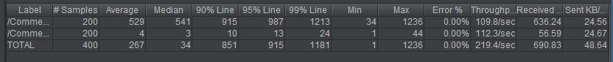

1. 加载窗口

* 顺序访问

Summary Report



Aggregate Report

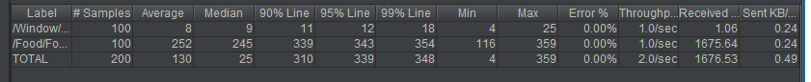

* 同时访问

Summary Report

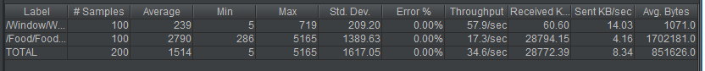

Aggregate Report

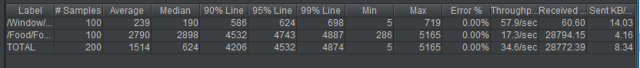

1. 食物排序



* 顺序访问

Summary Report



Aggregate Report

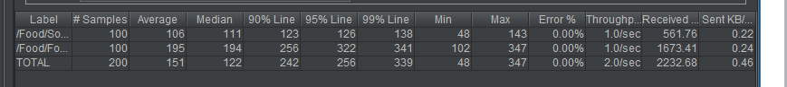

* 同时访问

Summary Report



Aggregate Report

